**Biorefrigerator Security System**

Biomedical Engineering Senior Design

Dr. Aijun Wang

Progress Report 2

Winter 2024

Team 1

Brayden Chipman - 1/24/24 11:07 PM

Miguel Cruz - 1/24/24 11:07 PM

Ashwin Halepet - 1/24/24 10:42 PM

Vance Padilla - 1/24/24 11:07 PM

**Table of Contents**

# 

**Problem and Objective 2**

Problem 2

Objective 2

**Concept Generation 3**

Concept Generation Flow Chart 3

Primary Design Concepts 3

**Concept Screening 8**

Primary Screening 8

Secondary Screening 11

**Materials and Manufacturability 12**

Bill of Materials 13

Purchasing 14

Rapid Prototyping 14

**Detailed Drawings 15**

Concept 1 15

Concept 2 16

Concept 3, Final Concept Chosen, Initial Design 17

Concept 3: Current Version(3) 21

**References 29**

**Appendix 31**

Interview With Steven Lucero 31

Figure 16: User Needs Flowchart 32

Figure 17: Engineering Design Specifications 32

# **Problem and Objective**

Figure 1: Introductory Figure for the Design

# 

Above is the current prototype design for the lock sensor system. The device is a weighted system that can ensure that the door is closed but has light and sound alarm systems as a failsafe in case the door is left open. The progress report will go into more detail on this design in the Detail Drawings section.

## **Problem**

Current methods of ensuring that a frequently accessed controlled laboratory environment (CLE) remains closed are limited by the need for human input, which requires a human to physically close the CLE. Humans typically interact with the CLE by opening or closing the doors manually. Requiring the use of human input introduces the possibility of human error. However, older CLE models may not have a method to signal that it is accidentally left open. The most common error of human input in CLEs is accidentally leaving them open. This error can result in significant risk to the integrity of materials within them, such as DNA or cells.

## **Objective**

The objective of the Biorefrigerator Security System is to develop a device that minimizes the risk of sample deterioration due to prolonged exposure to ambient conditions. We aim for the device to be power efficient, affordable, easy to install, and easy to use. By both controlling and reporting the status of CLE doors, our device can be used by laboratory staff to autonomously close the doors. Primary intended use cases are CLEs such as chemical and biological laboratory refrigerators.

# **Concept Generation**

## Concept Generation Flow Chart

When designing a CLE door security device, we primarily considered two key factors: sensors and digital or analog components. Emphasizing simplicity was a primary concern to minimize human error and robustness for older CLEs. Our initial ideas only involved using the door, so therefore we decided to consider a hinge mechanism. We realized that considering the most ideal components in the design would help us decide what and how to design the device. By combining components and ideas that cover for each other’s weaknesses, we could create a product that efficiently satisfies our defined criteria. This is how we moved on to primary design concepts.

Figure 2: Mind Map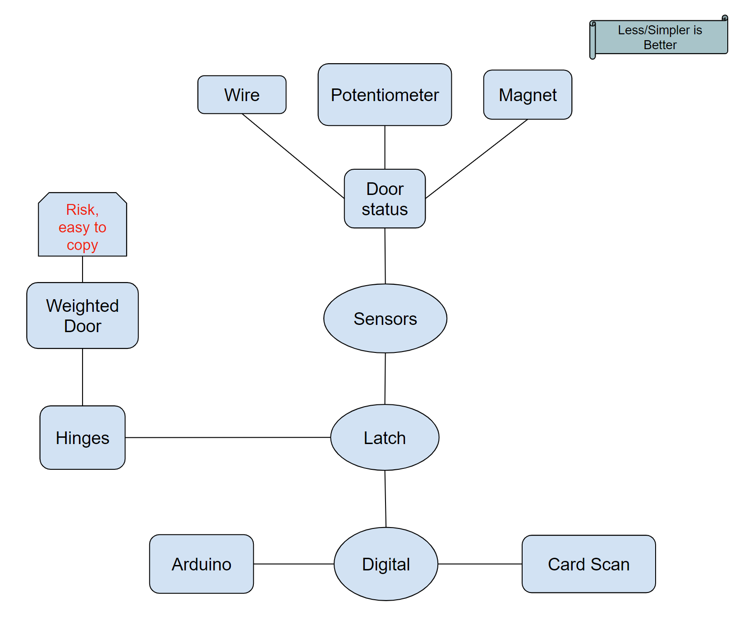

## **Primary Design Concepts**

When we looked back at our concept generation flow chart that we made, we realized that our prototype will be based on multiple different concepts that are integrated together. Our primary screening for our prototype is based on three components: detection, security, and alarm. Specific components we will screen are discussed below and will have a description of why each component was considered.

***Concept Component Section 1: Input(Detection/Status)***

All components listed below contribute to the detection or remote signaling of door status.

**Laser (Opto Slotted Switch)**

An infrared laser sensor will detect the open or closed status of the door. An LED attached to the door side of the design will shine a light onto a phototransistor, which will cause it to conduct when the CLE door is closed. The conductance of the phototransistor will determine the closed state. If the CLE door is open, then the laser will move with the door and the phototransistor would not conduct [1]. The laser component was chosen due to the simple nature of the design, as well as the passive nature of applying it. In addition, infrared sensors that function similarly are commonly used in households, making it a very established technology.

**Magnetic**

A simple coiled magnetic sensor consists of three main components: a magnet, a coil, and a device to measure current or voltage. By attaching the magnet to the door of the CLE and the coil to the main body, the opening and closing of the door will act as the movement for the magnet. When the magnet and coil are separated more, the coil will decrease the induced current applied to the coil, which then can be interpreted as the doors being open [2]. Utilizing the motion of the door moving away from the body of the CLE would make the implementation of a coiled magnetic sensor simpler.

**Temperature**

A temperature sensor, or thermocouple, would be placed on the inside of the CLE. A thermocouple works by measuring the net open current voltage at the cold junction between two dissimilar metal wires. This net open circuit voltage is a function of the temperature and composition of the two wires. Temperature and voltage are then correlated in order to report temperature [3]. The temperature is kept at a certain temperature inside the CLE, and when open, the temperature increases as ambient heat transfers into the CLE. If the temperature increases past a user-specified point, then the sensor will detect that the CLE has been left open for too long. This technology is also well established, and temperature is one of the main factors that must be controlled in order to preserve materials in CLEs. Temperature sensors do require calibration every so often to ensure they are accurate. In order to upkeep temperature sensors, regular calibration tests should be performed and ensure that the temperature sensors are handled and stored properly.

**Weighted**

An automatic weighted door will actively close the CLE if the door is left open. The weighted closing system is based on existing automatic door closers, which a mechanical hydraulic device. Springs are used to exert force onto the door to close it when it is open, while the hydraulic components are used to control the speed of closing by moving closer to or further away from the spring [4]. This component was chosen because of the ability to change the status of the door as opposed to monitoring it. It was also a robust system for automatic door closing that minimized user interaction so as to not impede the work of laboratory workers.

**Wire**

A steel cable with a nylon coating will be set between the CLE’s door and main compartment. The wire, or cable, will be held in a retractable cord reel. Retractable cord reels utilize a torsion spring mechanism to build tension when the cable is pulled. After the door is let go, the potential energy in the torsion spring is released and used to retract the cable [5]. Hooke’s law is used to calculate the amount of force that is exerted on the door during retraction. This method was considered due to the existence of retractable cable reels in the market already, as well as the ability to autonomously close the CLE door.

**Rotary Potentiometer**

A rotary potentiometer can be placed at the hinge of the door and can detect the door’s status. Potentiometers work by utilizing the fact that an object’s resistance is directly proportional to its length. A rotary potentiometer works by moving a sliding contact across a uniform resistive strip. Changing the length of the path that current flows through effectively changes the effective resistance [6]. The angle that the potentiometer is at when the door is closed will determine the reference resistance. From this, a reference voltage can be calculated and the sensor can be calibrated. Changes in the resistance from the reference will correlate to an increase in output voltage due to the voltage divider circuit [7]. The linearity of rotary potentiometers also means that the degree that the door is opened to can be easily calibrated to output voltages. Additionally, the rotary potentiometer needs to be frequently calibrated to ensure accuracy because of wear from lots of usage, as well as mechanical stress over time due to repeated use.

***Concept Component Section 2: Input(Security/Verification)***

All of the following components below are based on security factors to check who opens the door.

**PIN Pad**

Using a PIN pad can allow people who only know the passcode to enter or have everyone have their own passcodes to know who specifically opens the CLE door. A PIN pad system is a type of number code system where when a code for the CLE door is entered, the CLE system will be opened or closed. The reason why this idea was considered is because using a PIN pad is another intuitive way to unlock a CLE and disarm an alarm since all it takes to use a PIN pad is to type in a short code and that is it.

**Finger Pad (Optical Fingerprint Sensor)**

An optical fingerprint sensor can be used to access the door while knowing who specifically opened the door. The sensor itself uses LEDS to create a scan of one’s fingerprint using a charged-coupled device(CCD). A CCD uses an array of pixels that respond to light hitting the sensor in order to generate an image that captures the ridges and valleys of a person’s fingerprint[9]. By comparing a scanned fingerprint to those registered by the operator in a database, the microcontroller can determine if the user is authorized or not. The reason why this idea is considered is because this method ensures that only authorized users can access the CLE while making it easy to add new users to that pool. In addition, the scanner does not require the user to carry any extra authentication with them, such as a key or card.

**Card Reader**

Most labs in UC Davis have an RFID card for each person who works in a lab. RFID cards work by using low-power radio frequencies to collect and store data. A transceiver reads and then transmits radio frequencies to the cards. The cards themselves will be RFID tags that contain small computer chips that can transmit data to the RFID reader. We can use a card with the CLE lock to tell who is opening the door since the preexisting security systems of the building include a tracking system that can be used to identify the user of the card through transmissions from the card’s chip [8]. The card reader will be a way to verify a person authorized to use the contents of the CLE is opening the door instead of someone else, especially since some lab areas (such as our client’s) have multiple groups using the same space [8]. This idea was considered since using card readers comes naturally for many people as IDs and credit cards are commonly used in people’s daily lives so ID usage is very user-intuitive. Furthermore, using an idea to unlock CLE’s is simple since all it takes is placing a card near the scanner to verify.

***Concept Component Section 3: Alarm/Notification***

All of the following components are supposed to alert the user by notification or alarm. Having no alarm is also an option as well.

**Digital**

A digital notification would send an alert to the phone or computer of the administrator of the lab from an application. This solution necessitates either an internet connection in order to use Firebase Cloud Messaging (FCM) or another system to send notifications and dictate when to send them [12]. For this device, we will send a notification whenever our detection system finds the door to the CLE open. The signal of the circuit will be triggered when the door is in a position that is not the usual closed position and will send a notification to notify a user that the CLE is open.

**Sound Alarm**

A sound alarm on the device can alert those in the area by creating an audible noise that a CLE has been left open and that the samples inside are prone to denaturing or being compromised. A sound alarm can also create a sense of urgency or annoyance that will compel a user to close the CLE in order to stop the alarm. The sound alarm will be connected to the circuit board. What will trigger the sound alarm to activate is if there’s any movement within the sensor outside of what it senses as a closed position of the CLE, the signals will be sent from the sensor to the sound alarm, and then the sound alarm will activate an audible noise.

**Light Alarm**

A light alarm on the device can provide an easy visual alert for a user to see that the CLE has not been shut all the way for the user to prevent the samples from degrading due to the CLE being open for too long. Additionally, a strobing light can act as a silent alarm to alert users who may be hard of hearing or deaf. Similarly to a sound alarm, the light alarm is connected to the circuit board, and it is triggered if the sensor attached to the CLE door senses some form of difference in the position from a closed-door position, which will send an oscillating voltage to the alarm to make the LED strobe[13].

**No Alarm**

Having no notification system could be feasible with solutions that guarantee the door closing when left open. Furthermore, it requires no extra materials. This solution comes with the downside that, should the closing device malfunction, no one would know without manually checking.

# 

# **Concept Screening**

## Primary Screening

Table 1: Primary Screening of Input Method Concepts (Detection)

| **Input(Status/Verification)** | Concept Variants | | | | | | |
| --- | --- | --- | --- | --- | --- | --- | --- |
|  | Laser/Optical | | Magnetic | | Temperature | |
| **Selection Criteria** | Weight | Rating | Weighted Score | Rating | Weighted Score | Rating | Weighted Score |
| **Power Delivery** | 10% | 3 | 0.3 | 3 | 0.3 | 4 | 0.4 |
| **Affordability** | 10% | 4 | 0.4 | 4 | 0.4 | 3 | 0.3 |
| **Longevity** | 5% | 3 | 0.15 | 5 | 0.25 | 3 | 0.15 |
| **Ease of Use/User Friendliness** | 25% | 5 | 1.25 | 4 | 1 | 5 | 1.25 |
| **Ease of Handling/Accessibility** | 10% | 4 | 0.4 | 3 | 0.3 | 5 | 0.5 |
| **Ease of Manufacturing** | 20% | 4 | 0.8 | 3 | 0.6 | 3 | 0.6 |
| **Practicality (Is it Ideal/Proven to work?)** | 15% | 5 | 0.75 | 2 | 0.3 | 5 | 0.75 |
| **Security** | 5% | 2 | 0.1 | 2 | 0.1 | 1 | 0.05 |
| Score |  | 4.15 | | 3.25 | | 4 | |
|  |  | Weighted | | Wire | | Rotary Potentiometer | |
| **Selection Criteria** | Weight | Rating | Weighted Score | Rating | Weighted Score | Rating | Weighted Score |
| **Power Delivery** | 10% | 5 | 0.5 | 5 | 0.5 | 4 | 0.4 |
| **Affordability** | 10% | 3 | 0.3 | 5 | 0.5 | 4 | 0.4 |
| **Longevity** | 5% | 4 | 0.2 | 5 | 0.25 | 4 | 0.2 |
| **Ease of Use/User Friendliness** | 25% | 5 | 1.25 | 4 | 1 | 5 | 1.25 |
| **Ease of Handling/Accessibility** | 10% | 5 | 0.5 | 3 | 0.3 | 5 | 0.5 |
| **Ease of Manufacturing** | 20% | 4 | 0.8 | 4 | 0.8 | 4 | 0.8 |
| **Practicality** | 15% | 5 | 0.75 | 5 | 0.75 | 3 | 0.45 |
| **Security** | 5% | 1 | 0.05 | 4 | 0.2 | 1 | 0.05 |
| **Score** |  | 4.35 | | 4.3 | | 4.05 | |
| Notes |  | Doesn't need alarms | | Possible entanglement | |  | |

Table 2: Primary Screening of Authentication Method Concepts (Security)

|  |  | PIN Pad | | FingerPad | | Card | |
| --- | --- | --- | --- | --- | --- | --- | --- |
| **Selection Criteria** | Weight | Rating | Weighted Score | Rating | Weighted Score | Rating | Weighted Score |
| **Power Delivery** | 10% | 3 | 0.3 | 3 | 0.3 | 3 | 0.3 |
| **Affordability** | 10% | 3 | 0.3 | 2 | 0.2 | 2 | 0.2 |
| **Longevity** | 5% | 5 | 0.25 | 2 | 0.1 | 3 | 0.15 |
| **Ease of Use/User Friendliness** | 25% | 5 | 1.25 | 3 | 0.75 | 3 | 0.75 |
| **Ease of Handling/Accessibility** | 10% | 4 | 0.4 | 3 | 0.3 | 4 | 0.4 |
| **Ease of Manufacturing** | 20% | 4 | 0.8 | 2 | 0.4 | 3 | 0.6 |
| **Practicality** | 15% | 5 | 0.75 | 5 | 0.75 | 5 | 0.75 |
| **Security** | 5% | 5 | 0.25 | 5 | 0.25 | 4 | 0.2 |
| Score |  | 4.3 | | 3.05 | | 3.35 | |

Table 3: Primary Screening of Notification Method Concepts (Alarm)

| **Notifications** | Concept Variants | | | | | | | | |
| --- | --- | --- | --- | --- | --- | --- | --- | --- | --- |
|  | Digital | | Sound Alarm | | Light Flashing | | No Alarm | |
| **Selection Criteria** | Weight | Rating | Weighted Score | Rating | Weighted Score | Rating | Weighted Score | Rating | Weighted Score |
| **Power Delivery** | 10% | 2 | 0.2 | 3 | 0.3 | 3 | 0.3 | 5 | 0.5 |
| **Affordability** | 10% | 2 | 0.2 | 4 | 0.4 | 4 | 0.4 | 5 | 0.5 |
| **Longevity** | 5% | 2 | 0.1 | 3 | 0.15 | 3 | 0.15 | 5 | 0.25 |
| **Ease of Use/User Friendliness** | 25% | 3 | 0.75 | 4 | 1 | 4 | 1 | 1 | 0.25 |
| **Ease of Handling/Accessibility** | 10% | 4 | 0.4 | 5 | 0.5 | 5 | 0.5 | 1 | 0.1 |
| **Ease of Manufacturing** | 20% | 3 | 0.6 | 5 | 1 | 5 | 1 | 5 | 1 |
| **Practicality** | 15% | 4 | 0.6 | 5 | 0.75 | 4 | 0.6 | 1 | 0.15 |
| **Security** | 5% | 5 | 0.25 | 3 | 0.15 | 2 | 0.1 | 1 | 0.05 |
| Score |  | 3.1 | | 4.25 | | 4.05 | | 2.8 | |
| Notes |  | Possibly use as secondary aspect | |  | |  | |  | |

Looking at the primary screening on Table 1,2 and 3, we rated each component based on the following criteria: power delivery, affordability, longevity, ease of use/user friendliness, ease of handling/accessibility, ease of manufacturing, practicality, and security. Each of these comes from an updated version of the User Needs Flowchart. To clarify the differences between ease of use and ease of handling, ease of use is a customer's ability to quickly understand how to use the product while ease of handling is a customer’s ability to physically interact with the product. Practicality is to determine whether previous devices using the component were used well or well received. Security, while initially thought to be highly prioritized, has significantly less weight as security has been proven to be high through other means around the lab. Overall, the ease of use and ease of manufacturing was set to have the highest weight. We want the customer to be able to quickly understand our product and we want to have easy manufacturing in order to have quick prototyping and quick reiterations of the device.

We divided all components into different color categories: red, yellow, and green. The red category means that the component is poorly rated. After checking and talking with the team, the red components were not considered to move on to the secondary screening. The yellow categories could have been well-rated overall, but they will not move on to the secondary screening after proper deliberations between team members. For example, the wire system was highly rated, but it still seemed very intruding and obstructive to people wanting to open the door no matter where we placed it since a wire system would end up being tough to untangle and maneuver, and therefore, was moved to the yellow category. Finally, the green components were selected based on their high rating as well as being well received between team members and therefore, moved onto the secondary screening. Green-rated systems indicate that they are not too difficult to manufacture, take up a reasonable amount of space, and include user-friendly methods for interacting with the system. Note that we did not blindly select random green components for our secondary screening, but rather deliberated over which components would work best in the green category. Overall, we made 3 concept ideas to be put together for the secondary screening.

## 

## Secondary Screening

Table 4: Secondary Screening Table

| **Concepts** | Concept Variants | | | | | | |
| --- | --- | --- | --- | --- | --- | --- | --- |
|  | Concept 1 (Laser Sensor) | | Concept 2 (Rotary Potentiometer + PIN Pad) | | Concept 3 (Weight + PIN Pad) | |
| Selection Criteria | Weight | Rating | Weighted Score | Rating | Weighted Score | Rating | Weighted Score |
| Power Delivery | 10% | 3 | 0.3 | 3 | 0.3 | 4 | 0.4 |
| Affordability | 10% | 4 | 0.4 | 3 | 0.3 | 4 | 0.4 |
| Longevity | 5% | 3 | 0.15 | 4 | 0.2 | 4 | 0.2 |
| Ease of Use/User Friendliness | 25% | 5 | 1.25 | 4 | 1 | 5 | 1.25 |
| Ease of Handling/Accessibility | 10% | 4 | 0.4 | 4 | 0.4 | 4 | 0.4 |
| Ease of Manufacturing | 20% | 4 | 0.8 | 4 | 0.8 | 4 | 0.8 |
| Practicality (Is it Ideal/Proven to work?) | 15% | 5 | 0.75 | 4 | 0.6 | 5 | 0.75 |
| Security | 5% | 2 | 0.1 | 5 | 0.25 | 4 | 0.2 |
| Score |  | 4.15 | | 3.85 | | 4.4 | |
| Rank |  | 2 | | 3 | | 1 | |

For our secondary screening, we created 3 concepts. We will go over these concepts in more detail in our detailed drawings sections where example designs are shown. To put simply, the first concept involved just the laser component, the second with the rotary potentiometer and PIN pad, and the third with the weighted door and PIN pad. All three concepts include sound and light alarms. These concepts will be our initial prototypes for our devices and we will reiterate and change as we go. Selection criteria remained the same and the highest score of the three will not automatically be chosen as the prototype to work on, but rather deliberated over then chosen. The initial concept drawings will be in the Detail Drawings section later on in the progress report.

Result: Concept 2 was the best choice decided by our team. We took into account the scoring of the other concepts and deliberated rather than just accepting the highest score and going with that concept. Having the concept 3 prototype (weighted door and PIN pad) seems best as it actively closes the door meaning considering the door being left open is less likely. The alarms provided in the concept will be emergency alarms just in case the weighted door fails.

Overall, we realized that instead of checking the status of the door, we can instead work on changing the status of the door when it is in an open state.

# 

# **Materials and Manufacturability**

# 

A couple of issues that arose from the initial design were the material choice, implementation of the rotary potentiometer, wiring, and methods of attachment. After meeting with Steven Lucero from the TEAM Lab, a few modifications were made to the initial design concept that we had created. In terms of the external design itself, not much was changed aside from the expansion of the surface that would connect to the top of the CLE. The manufacturing process of the finalized design will include the machining of aluminum for the body. Interior parts that do not experience significant stress will be 3D printed. The conversation with Steven Lucero can be found in the appendix for reference. The sheets of aluminum will be cut with a band saw and welded to create the box shape, then grinded down to refine the final look.

For the PIN pad case, we decided on a body that is made of 6061 aluminum as it is manufacturable and durable for the purposes of this project. We will have a microcontroller system in order to code the alarms, PIN pad, servo, and potentiometer system. Entering a passcode in the PIN pad will unlock the door by rotating the servo so the closer arm is unblocked, signaling this with a solid green light from a dual LED. Entering the code again will lock the closer arm and change the LED to solid red. The potentiometer will be calibrated to measure the rotation of the closer arm so it can detect when the CLE door is open or closed. In the event that the door is either open for over 5 minutes or has opened while locked (which will necessitate breaking the lock), then the speaker will sound an alarm and the LED will start blinking red.

## 

## Bill of Materials

Table 5: Bill of Materials

| **Component** | **Material** | **Purchasing Location** | **Part Number** | **Quantity** | **Weight** | **Price Per Unit** | **Total Price** | **Notes** | **Link** |
| --- | --- | --- | --- | --- | --- | --- | --- | --- | --- |
| **6061 Aluminum** | 6061 Aluminum | Amazon | N/A | 2 | 1.755 lbs per sheet | $18.99 | $37.98 | The body for the PIN pad | [6061 Aluminum](https://www.amazon.com/Aluminium-Aluminum-Finely-Polished-Deburred/dp/B08M63VD66/ref=asc_df_B08M63VD66/?tag=hyprod-20&linkCode=df0&hvadid=507685853899&hvpos=&hvnetw=g&hvrand=13803444464249626083&hvpone=&hvptwo=&hvqmt=&hvdev=c&hvdvcmdl=&hvlocint=&hvlocphy=1013763&hvtargid=pla-1244865546405&psc=1&mcid=73ecb0c2c16c363090a3ab1a556c41a9&gclid=CjwKCAiAqY6tBhAtEiwAHeRopVNa8dwxIhKlyLCnpZvd1lSsjFA1dELC7lDzbDw5YA9n06tZS93lMhoC3QAQAvD_BwE) |
| **Screws** | 18-8 Stainless Steel | McMaster-Carr | 97613A529 | 1 | ~0 | $17.36 | $17.36 | For the Body attachment. 10 Pack | [Screws](https://www.mcmaster.com/97613A529/) |
| **Adafruit METRO M0** | Microcontroller | Adafruit | 2488 | 1 | 0.042 lbs | $17.50 | $17.50 | Coding component for alarms, PIN pad, potentiometer | [Adafruit METRO](https://www.adafruit.com/product/3505) |
| **Red and Green Indicator LED** | LED | Adafruit | 4042 | 1 | Not Available | $1.75 | 1.75$ | Light Alarm | [RED/GREEN LED](https://www.adafruit.com/product/4042) |
| **PIN Pad** | N/A | Adafruit | 3845 | 1 | ~0 | $6.50 | $6.50 | The PIN pad itself | [PIN Pad](https://www.adafruit.com/product/3845) |
| **Wires** | PVC Coated Copper | Amazon | B08BBXTBL7 | 1 | 0.79 lbs total | $14.94 | $14.94 | Wiring for the device | [Wires](https://www.amazon.com/Gauge-Wire-Solid-Core-Hookup/dp/B08BBXTBL7/ref=sr_1_4?crid=2YFKFOA4RD63X&dib=eyJ2IjoiMSJ9.UIo5E3q7NzPjkxQwKGNfdQ3FuhAzLC-mAshupgLoSkDXkWJc1I1QggnkW8dAvnQAoPGPPllbJenMA18wVx0t9j-gmsoh0NwyJyPDq3IPxBP2T55pKQpW10vA9NtuKP_kZATr4Ul6AlKtvMASqldw9Q.xbG82dSqDf78ub71xgXVEjiEBb7RhIcGF8l26PJFpKs&dib_tag=se&keywords=wires&qid=1705265164&s=hi&sprefix=wire%2Ctools%2C199&sr=1-4) |
| **Potentiometer** | Potentiometer | Adafruit | 562 | 1 | Not Available | $0.95 | $0.95 | 10k kiloohms | [Potentiometer](https://www.adafruit.com/product/562) |
| **Adhesive (Epoxy)** | Epoxy Resin | Amazon | N/A | 1 | 0.125 lbs total | $12.45 | $12.45 | 2 pack, Metal Adhesive | [Epoxy Resin](https://www.amazon.com/J-B-Weld-Original-Reinforced-Strength/dp/B0B5VNG2YT/ref=asc_df_B0B5VNG2YT/?tag=hyprod-20&linkCode=df0&hvadid=598238944920&hvpos=&hvnetw=g&hvrand=16027891236110708106&hvpone=&hvptwo=&hvqmt=&hvdev=c&hvdvcmdl=&hvlocint=&hvlocphy=1013763&hvtargid=pla-1695224676408&mcid=13a156f4cdf13c26a20bfeb5266c44ce&gclid=CjwKCAiAqY6tBhAtEiwAHeRopf2Vh7qsXWIDqrsuZjqCuv6-VXtDVUysLzUv1R-RMKNJFESZMiPzWBoCWzAQAvD_BwE&th=1) |
| **Speaker** | N/A | Adafruit | 1891 | 1 | 0.01 lbs | $1.75 | $1.75 | Speaker for the alarm | [Speaker](https://www.adafruit.com/product/1891) |
| **Closer** | Aluminum | Amazon | ‎SOULONGg850ya231w | 1 | 2.31 lbs | $20.81 | $20.81 | Will use for hydraulic components | [Closer](https://www.amazon.com/Aluminum-Commercial-Automatic-Closing-Independent/dp/B08GPD3W6V/ref=asc_df_B08GPD3W6V/?tag=hyprod-20&linkCode=df0&hvadid=680463214693&hvpos=&hvnetw=g&hvrand=18051584580321407561&hvpone=&hvptwo=&hvqmt=&hvdev=c&hvdvcmdl=&hvlocint=&hvlocphy=1013721&hvtargid=pla-2260095885309&psc=1&mcid=624b2ed7d3513a4e9b84fd5e8e249870) |
| **Internal Brackets and other small parts** | PLA | UC Davis | N/A | As needed | ~0 | Variable | Variable |  |  |
| **Resistor** | 10kΩ 5% | Adafruit | 2784 | 1 pack | ~0 | $0.75 | $0.75 | For voltage divider | [10kΩ resistor](https://www.adafruit.com/product/2784) |
| **Battery Holder** |  | Adafruit | 67 | 1 | 0.05lbs | $3.95 | $3.95 |  | [Battery Holder](https://www.adafruit.com/product/67) |
| **Servo** | Micro Servo | Adafruit | 2307 | 1 | 0.03lbs | $11.95 | $11.95 |  | [Servo](https://www.adafruit.com/product/2307) |
| **Battery** | 9V battery | Amazon | N/A | 1 pack of 4 | 0.05lbs | $9.55 | $9.55 | Power source for device | [9V battery](https://www.amazon.com/Amazon-Basics-Performance-All-Purpose-Batteries/dp/B0774D64LT?th=1) |
| **Sum of Prices/Weights** |  |  |  |  | ~7 lbs |  | $158.19 |  |  |

Each component within the bill of materials will be explained at various points of the progress report.

## Purchasing

The components from the Bill of Materials will be purchased from their respective vendors, however, some may also be sourced from preexisting stock at UC Davis in order to save time in shipping. The Bill of Materials is based on the current idea for the final design and may be revised later on due to needs that have not arisen at this time.

## Rapid Prototyping

3D printing will be used for rapid prototyping of the design. PLA will be used in order to print the arms and main body of the case for prototyping purposes in order to minimize the time and budget spent on machining. The dollar amount spent on 3D printing will vary depending on the amount of times revisions may need to be done, and thus this will be calculated and added to the finalized version of the Bill of Materials once prototyping has concluded.

# **Detailed Drawings**

# 

## Concept 1

Our first concept is a laser detector door opening device with a sound and light alarm, addressing the need to reduce the risk of contents in frequently accessed CLEs from being compromised due to unexpected or prolonged access. The device employs a laser sensor, laser padding, and a light and sound box powered by AA batteries. By detecting the presence or absence of laser reflections off the phototransistors, the sensor determines whether the door is open. In the event of an open door, the device activates a light and sound alarm, alerting nearby individuals to the situation, and automatically deactivates when the door is closed. Despite concerns about security and longevity, the solution's quick and simple development, along with its ease of use, compensates for these drawbacks. The device's passive nature ensures minimal user interference, making it suitable for environments where active security measures may be impractical. Technical feasibility involves addressing precision challenges, exploring similar laser sensors, and identifying potential stimuli that could interfere, with an estimated prototype development and testing time of approximately four days. The solution's non-obvious and novel aspects include its passive operation and integration of alarm systems and laser sensors into a single physical unit, making it applicable in areas with limited network connectivity. Look at Figure 3 for the concept image.

Figure 3: Different Views of Concept 1

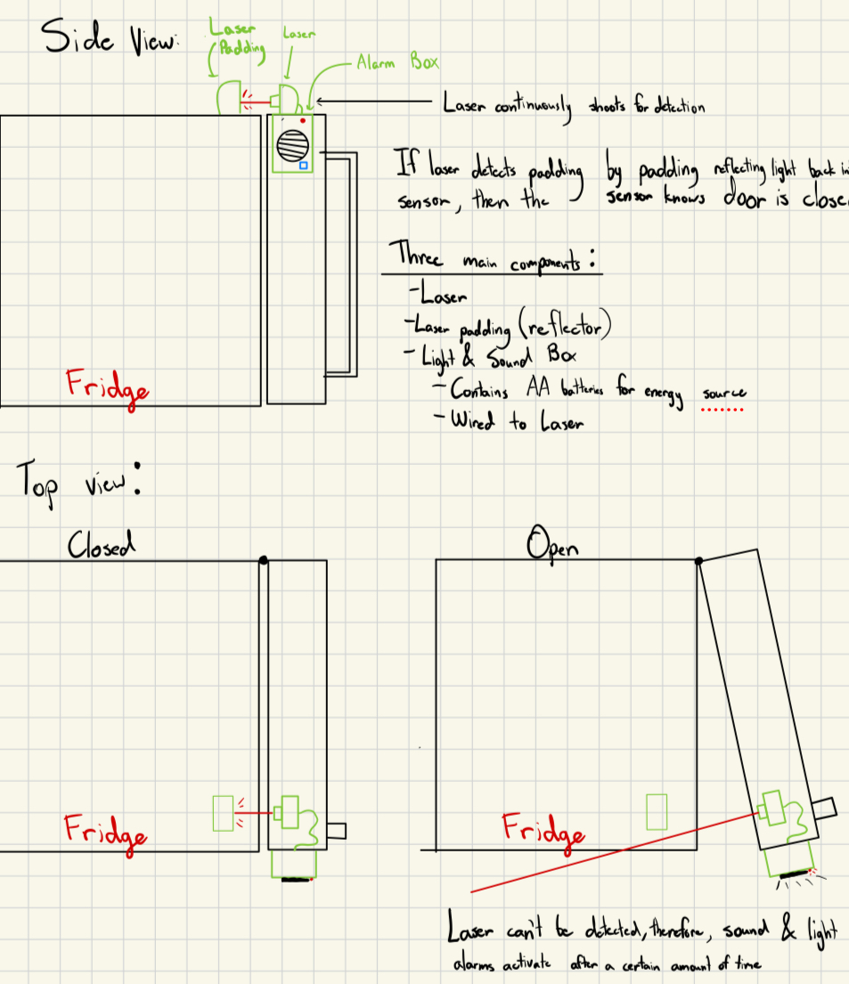

## Concept 2

The following concept involves the integration of a rotary potentiometer at the hinge of a CLE door, coupled with a PIN Pad and alarm system to address the need for enhanced security in frequently accessed CLEs. The PIN Pad allows users to input a code, disarming the alarms triggered by the rotary potentiometer, which monitors the door's open and closed status through a potentiometer. If the door remains open beyond a specified time, the alarms activate with sound and flashing lights. The key components include a motherboard, PIN Pad with LED, potentiometer, and a speaker box with AA batteries. This design utilizes the potentiometer to modulate electrical resistance, translating it into different voltage readings corresponding to the door's angle. Pros include non-obtrusive installation at the hinge and providing a precise, nuanced measurement of door openness. However, concerns revolve around affordability, potential variations in CLE hinge designs, and power consumption. In addition, different models of CLEs would have differing size needs when it comes to a hinge design. Technical feasibility is largely favorable, but questions about handling and power requirements need addressing. The concept's novelty lies in using a potentiometer for CLE security, offering a more nuanced approach than existing binary systems. Look at Figure 4 for the concept image.

Figure 4: Different Views of Concept 2

# 

## 

## 

## Concept 3, Final Concept Chosen, Initial Design

The final and chosen concept to start working for prototyping addresses the need for enhanced security and automatic door closure in frequently accessed CLEs. The design incorporates a weighted mechanism, utilizing a spring and sensor, to ensure reliable closure of the CLE door. A PIN pad lock provides a secure means of access, allowing users to input a passcode for unlocking and locking the door. Additionally, a sound and light alarm system activates if the CLE is opened without the PIN pad, requiring manual closure and passcode entry to disarm the alarm. The weighted mechanism serves a dual purpose, automatically closing the door after a specified time and acting as a failsafe in case of alarm-triggered failures. Despite potential concerns regarding ease of manufacturing, this concept excels in providing heightened security, ease of use, and practicality, addressing the critical need to prevent unauthorized access to the CLE's contents while not completely having to worry about the door being left open. These factors set it apart from previous prototypes, offering a unique and effective solution to enhance the overall security of frequently accessed CLEs. Look at Figure 5 for the first version of the concept image.

Figure 5: Version 1 of Concept 3

# 

This figure shows a rough concept of a case containing a PIN pad, speaker, and LED connected to an automatic door closer. This concept also contains a hidden sensor within an electronic closer device.

Figure 6: Version 2 of Concept 3, taking projected parts into account and using Solidworks. Case made of 6061 Aluminum.

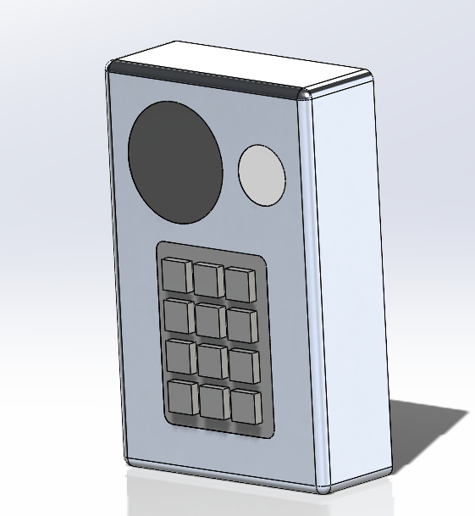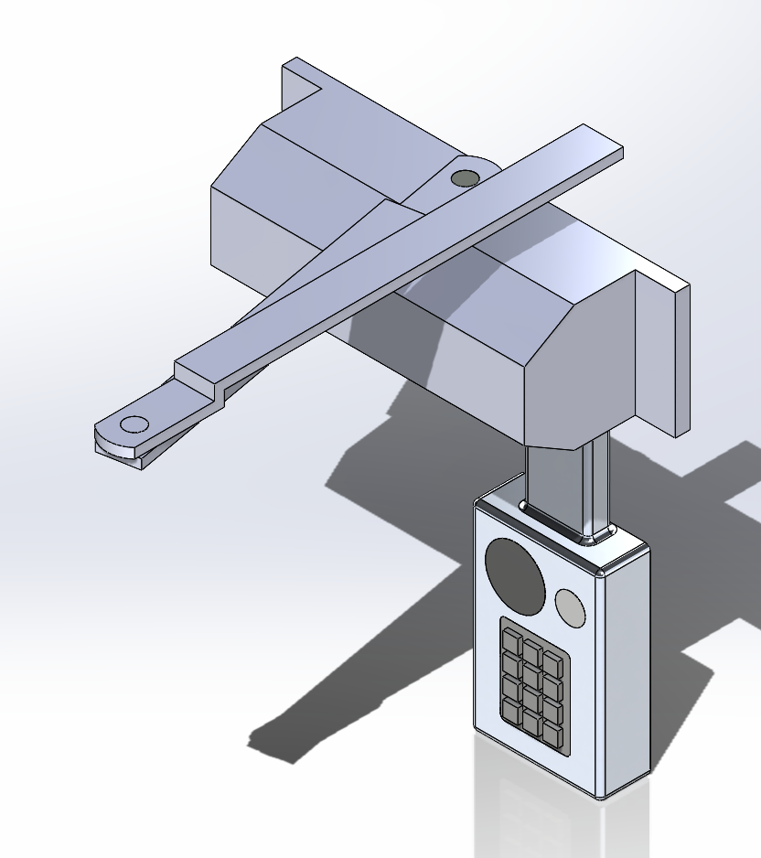

This new version takes concept three and establishes a clearer view of the design. Firstly, the design now has an appropriate sized hydraulic closer that looks like the one we will buy from the Bill of Materials shown on Table 5. The placement of the sound and light alarms are more detailed. The internal component where the pin pad, sound alarm, and light alarm are located allows a reasonable amount of space to insert the microcontroller as shown in Figure 8. The circuitry that will be internally placed in the box is shown on Figure 9. Lastly, we decided to use part of concept 2, the rotary potentiometer, into this design so the device can detect whether the door is left open for any reason. The placement of the potentiometer is more clearly shown on Figure 7.

Figure 7: Dimensioned Drawings of Version 2 Concept 3 using Solidworks (IPS units)

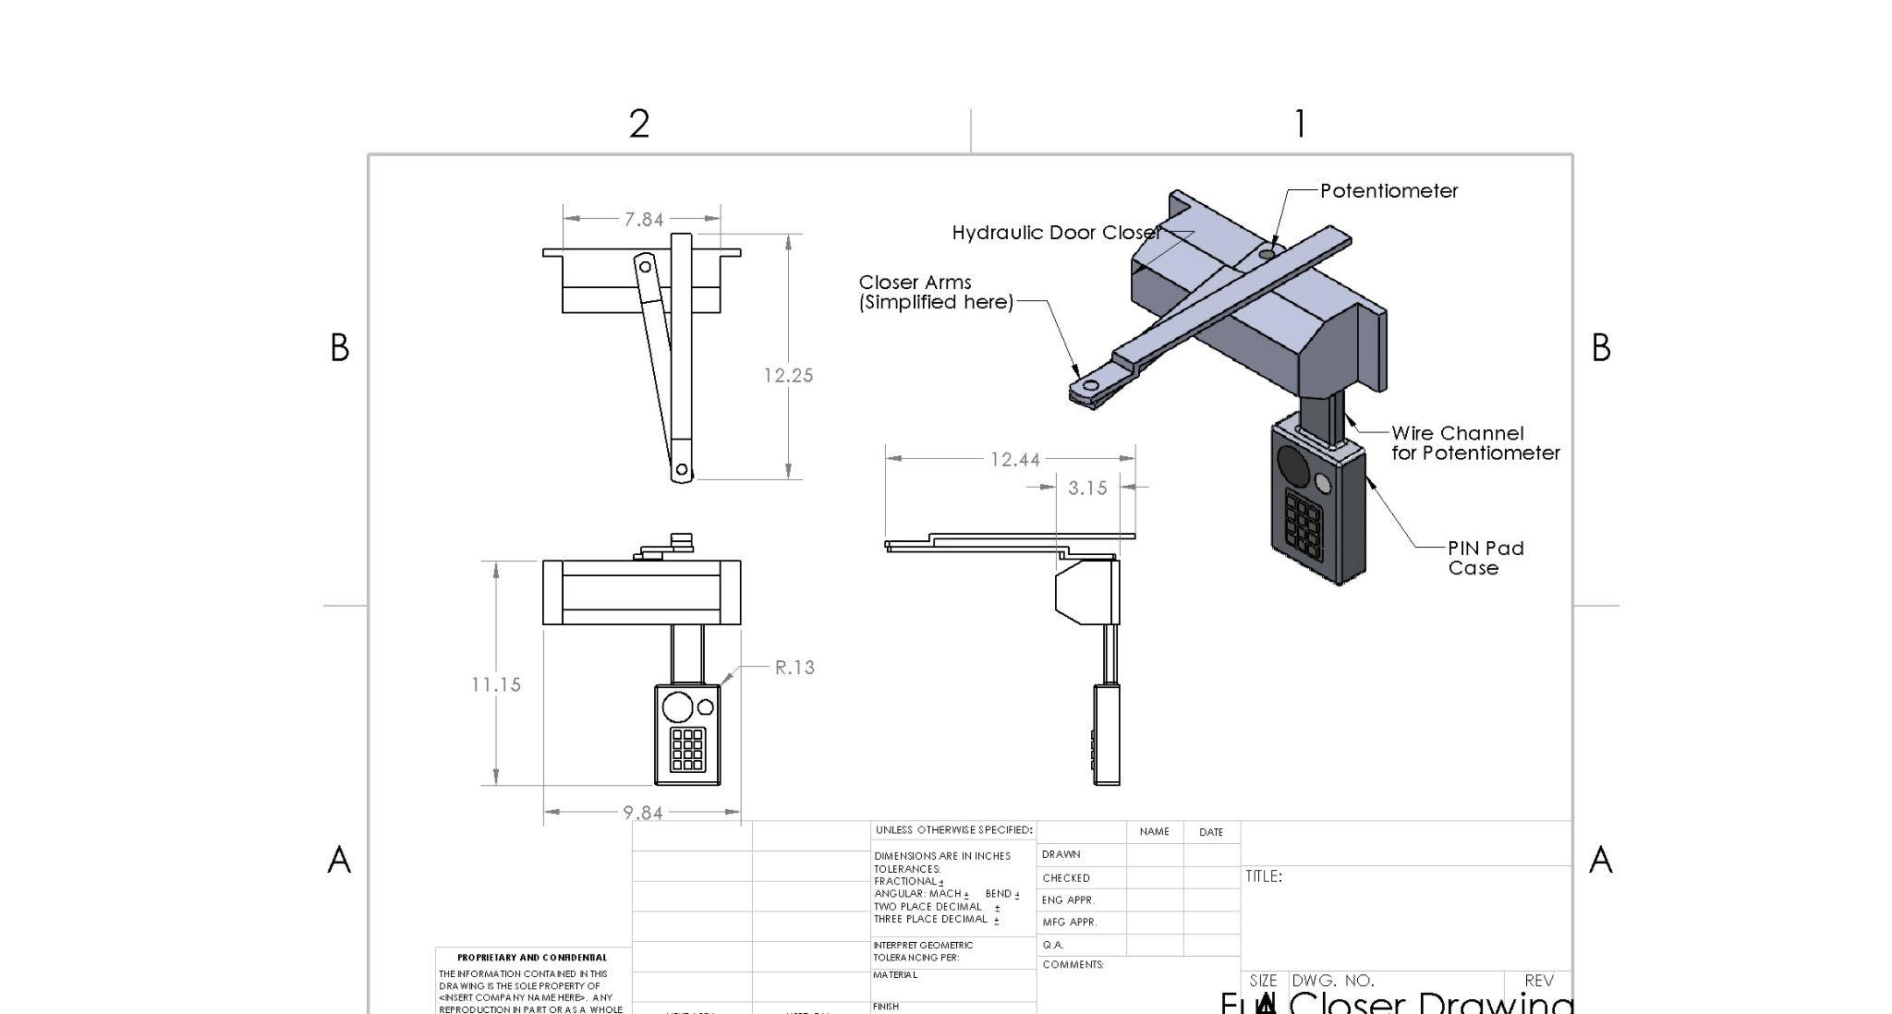

Figure 8: Dimensioned Drawings of Version 2 Concept 3 only PIN Pad component using Solidworks (IPS units)

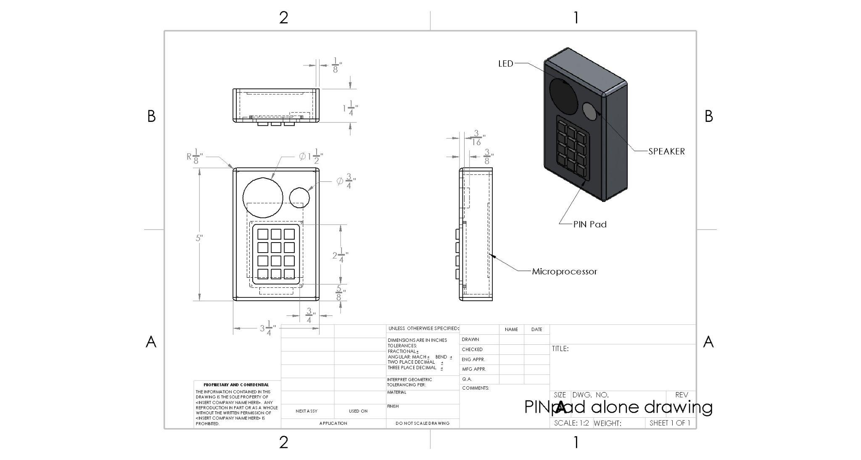

## Concept 3: Current Version(3)

Figure 9: Wiring Schematic of PIN Pad, Potentiometer, Battery, Adafruit Metro, and LED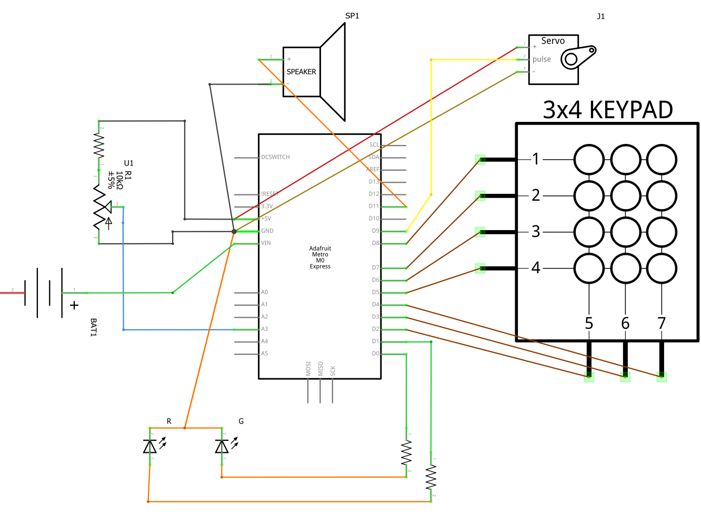

The wiring schematic can be broken down into the following parts: the potentiometer voltage divider, the battery holder, the LED circuit, the PIN pad, and the servo circuit. Each one is connected to the Adafruit Metro M0 Express.

For the potentiometer to measure the angle at which the door is open, a voltage divider is used, which will have a transfer function of

$V_{out}=\frac{R_{2}}{R_{2}+R_{1}}V_{in}$

$V_{out}$ is the voltage measured across the potentiometer, $R_{2}$ is the resistance of the potentiometer, $V_{in}$ is the supply voltage and $R_{1}$ is 10k $Ω$

As the potentiometer rotates, $R_{2}$ and $V_{out}$ change. After calibration, changes in the $\frac{R_{2}}{R_{2}+R_{1}}$ factor can be evaluated to determine the angle of the door in relation to this closed position.

The battery will provide the power for the circuit. The LED circuit will supply the green LED with 2.3 volts when the correct PIN code is entered if the device is locked and the red LED will be supplied if the device is unlocked. The keypad circuit will input the corresponding number to each button by using the coordinates of the button. The servo will be supplied with 5V, and the signal from the microcontroller through the pulse wire will determine its rotation. The other wire is a ground. The speaker will be supplied with 0.3W if the potentiometer detects the door opening when locked.

The pseudocode in the microprocessor will function as such:

Alarm_Determination:

Initialize PIN

If (PIN == TRUE && Lock_status == closed):

Lock_status = open

Else if (PIN == TRUE && Lock_status == open):

Lock_status = closed

If (Lock_status == closed && potentiometer == open):

Alarm == on

%%in the event of the lock being closed and the door being open

If (potentiometer == open for over 120 seconds):

Alarm == on

%%in the event of the door being propped open

If (Alarm == on && potentiometer == closed)

Alarm == off

Figure 10: Exploded view of the closer part. Source from Cherry Wong [11]

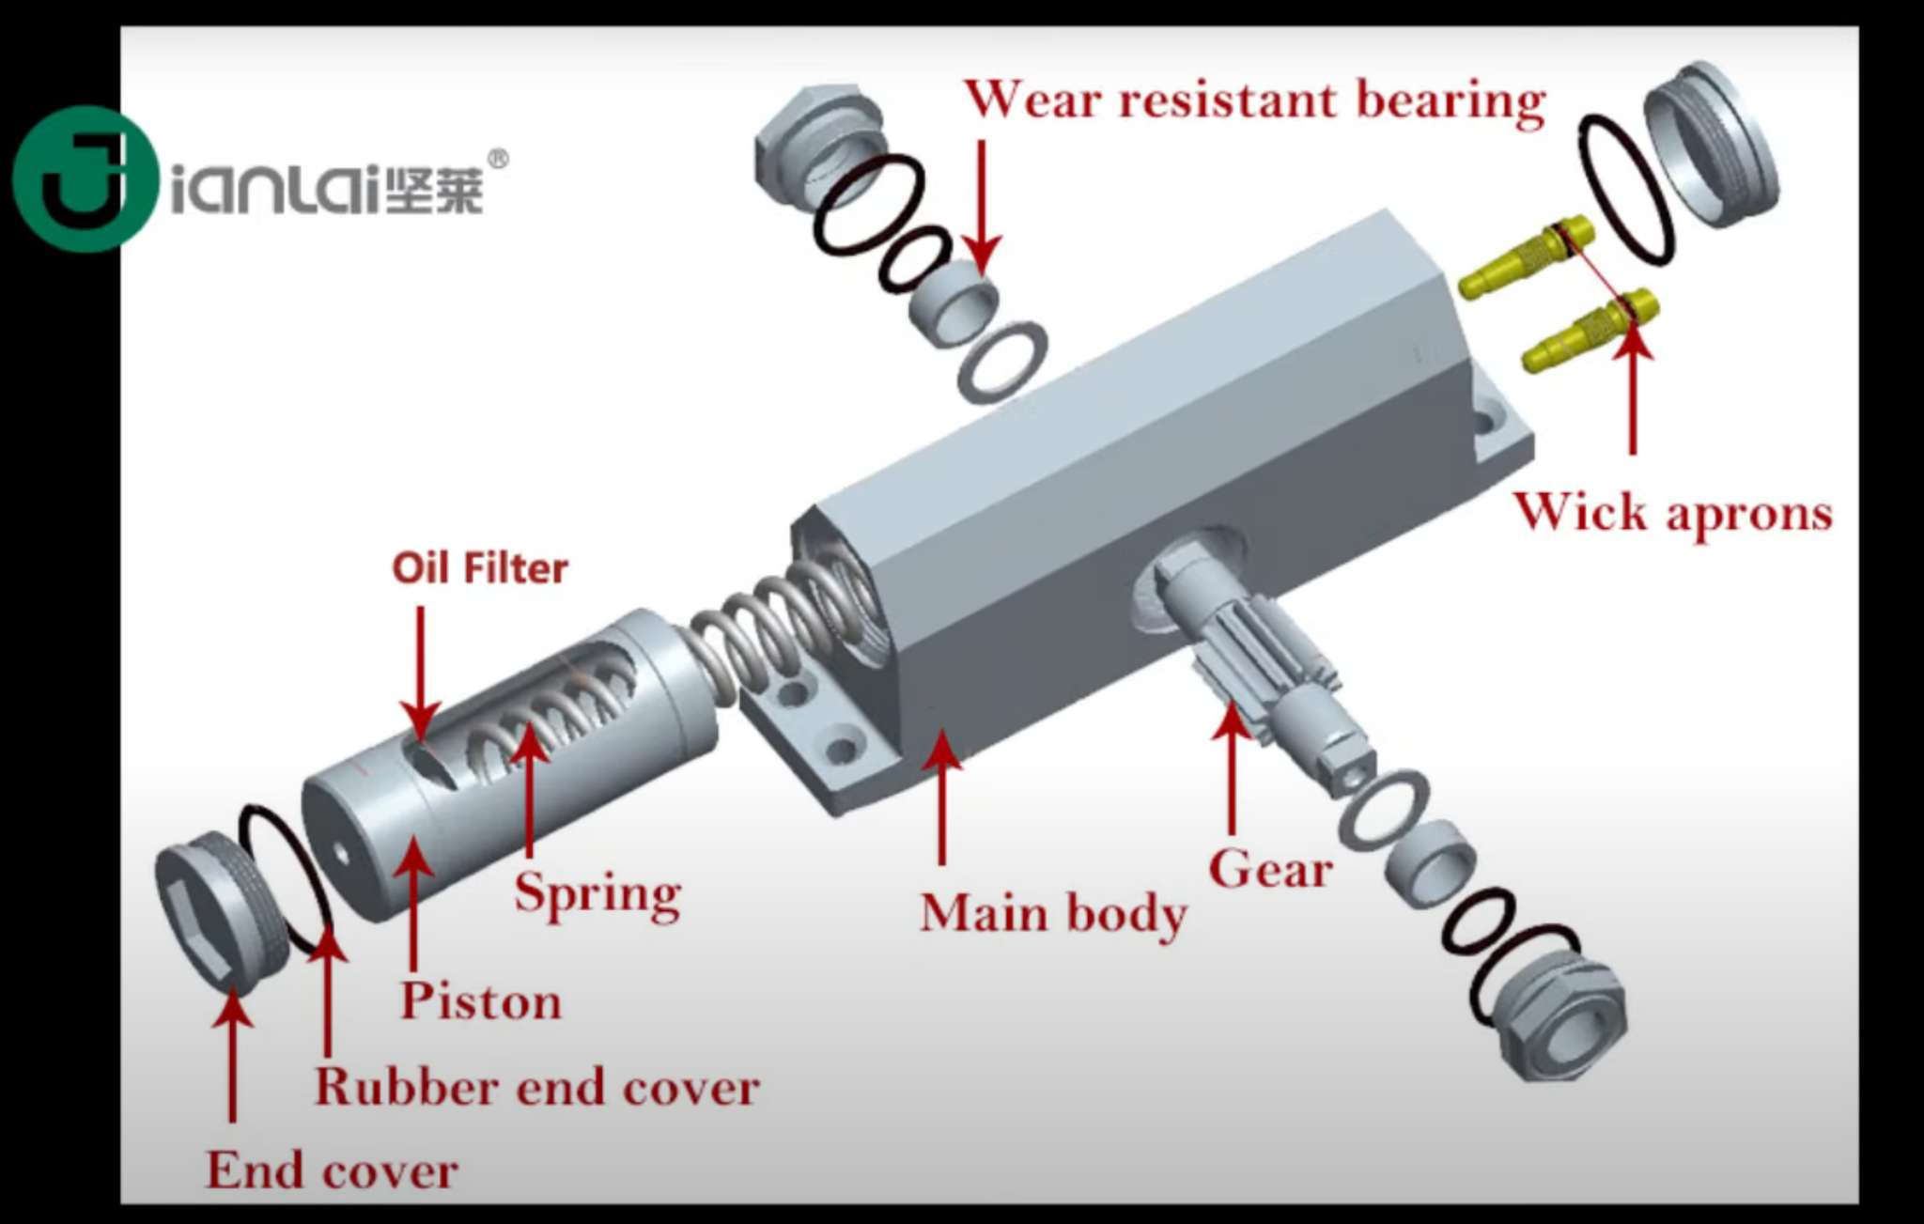

Pictured above is a standard hydraulic closer mechanism that is used for automatically closing doors. We have decided to work with a device that utilizes this mechanism to minimize error in producing a hydraulic mechanism from the ground up. After looking at patents for this design, many were filed in the early 2000s and are now expired [15].

Figure 11: Dimensioned Drawings of Version Concept 3 PIN Pad case using Solidworks (IPS units)

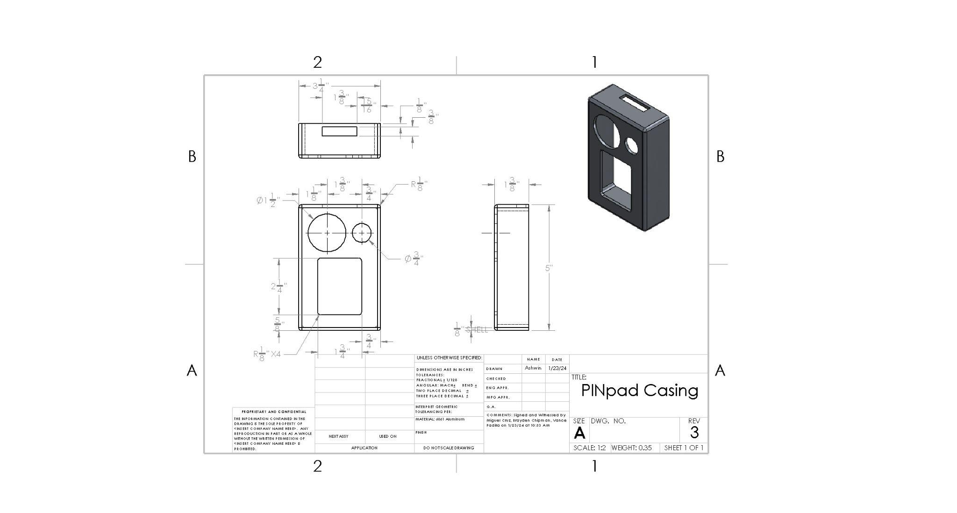

Figure 12: Dimensioned Drawings of Version 3 Concept 3 of Servo Bracket component using Solidworks (IPS units). Design will be subject to slight changes after prototyping in order to optimize for servo to stay in the bracket.

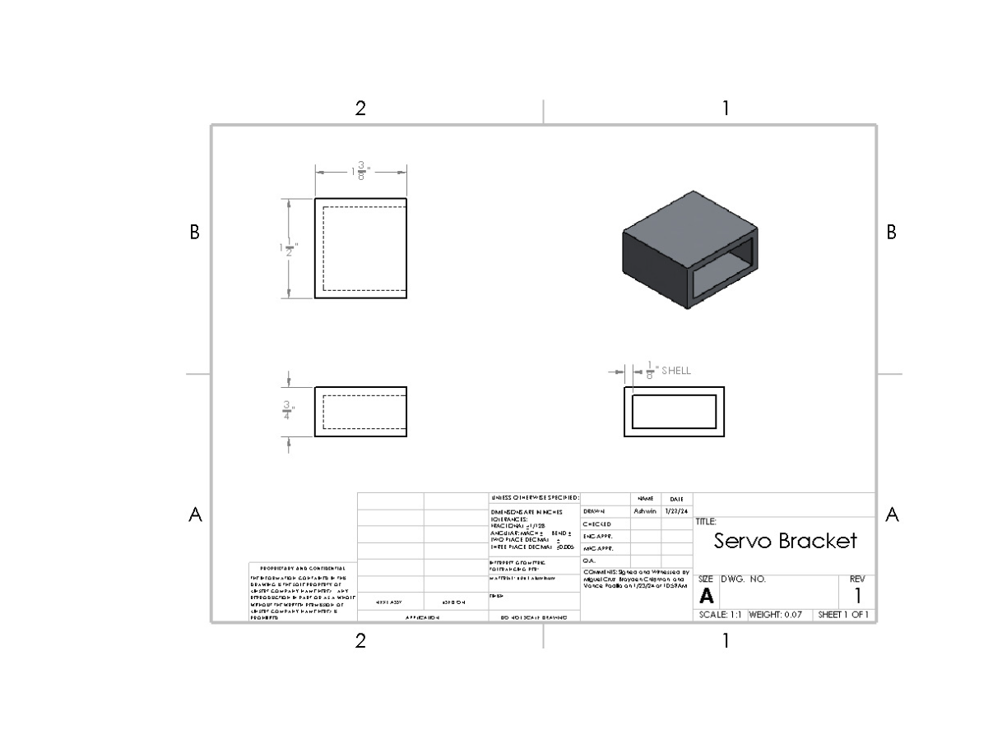

Figure 13: Dimensioned Drawings of Version 3 Concept 3 Hook Lock component using Solidworks (IPS units). The hole having a diameter of 0.2” is an estimation since the servo diameter is unknown.

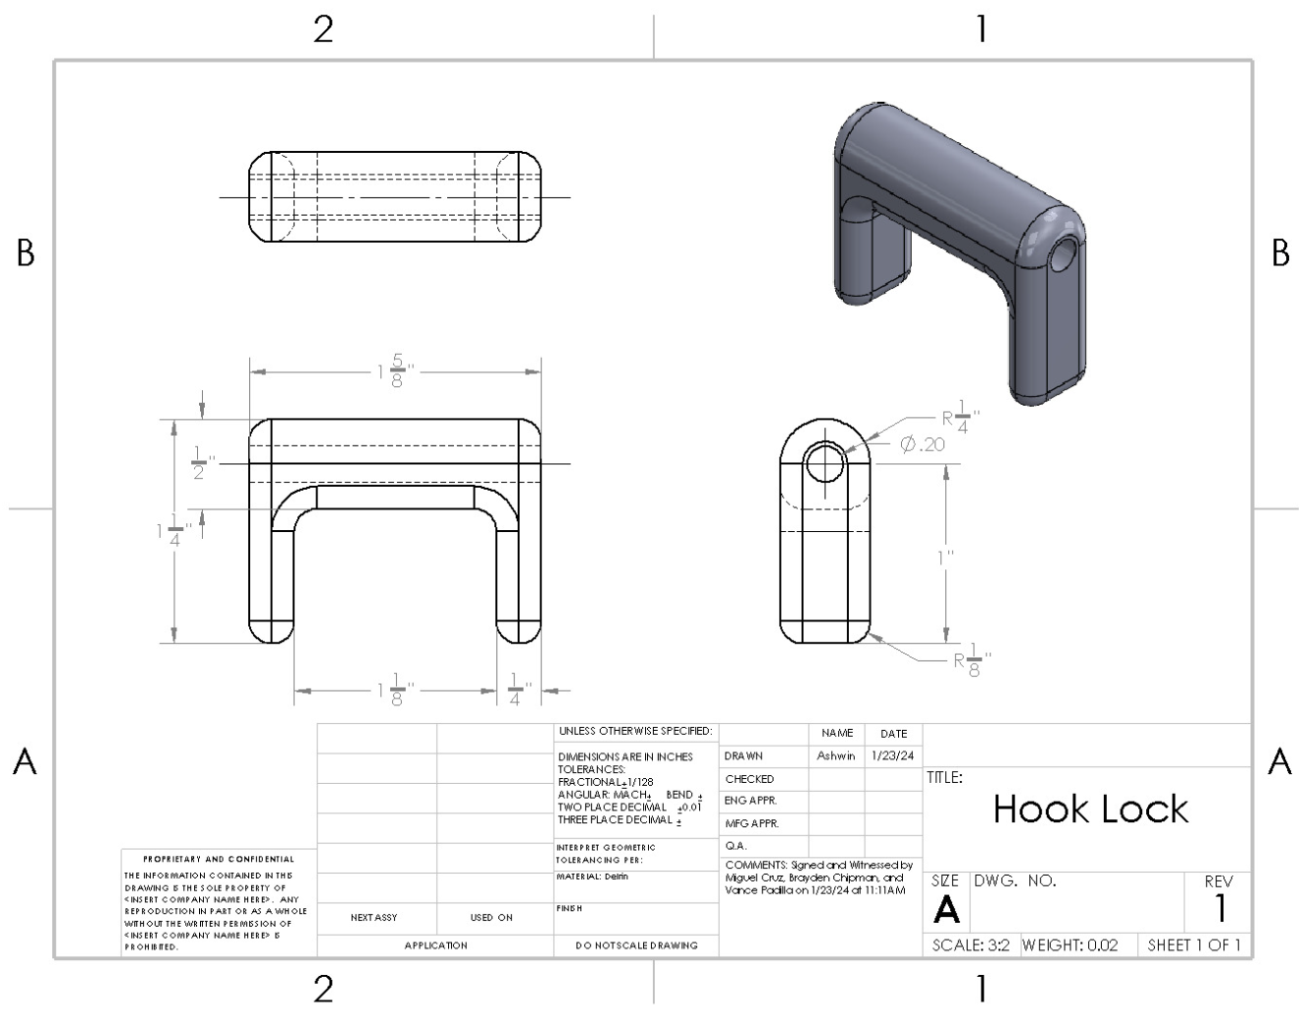

Figure 14: Dimensioned Drawings of Version 3 Concept 3 assembly using Solidworks (IPS units).

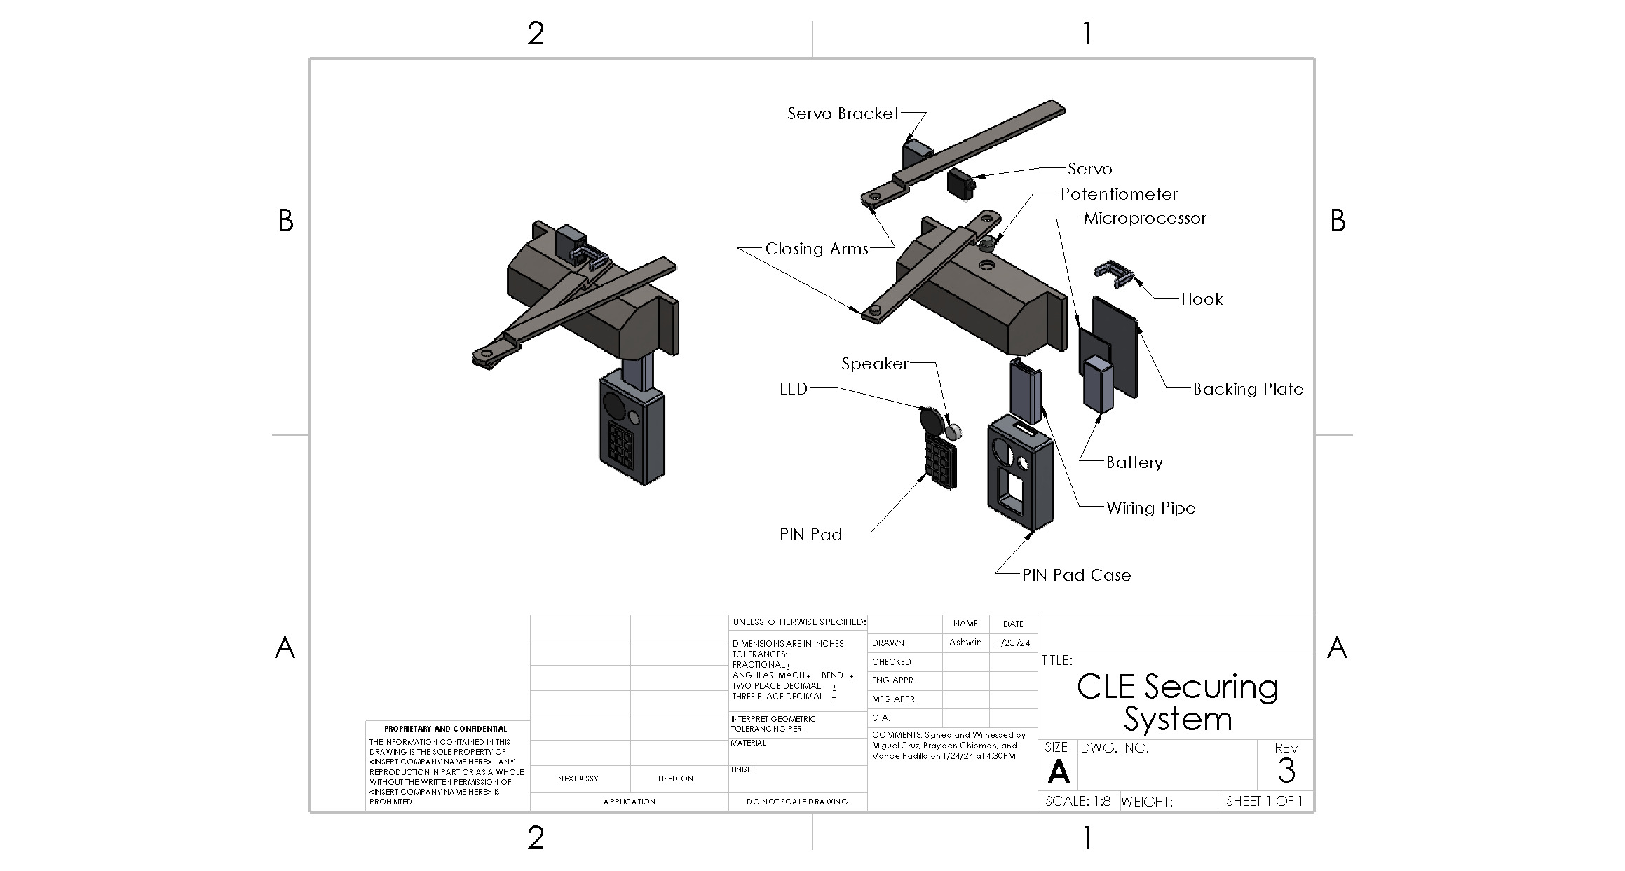

This new iteration of the weighted door has a few new changes to accommodate more aspects that have come up during group discussions. The PIN pad housing was made larger in order to fit the battery holder, and more wire channels were added for routing. We also added a servo and hook, which act as a locking mechanism for the device. The pin pad will be used to lock the weighted door with the hook.

When locked, the servo rotates the hook downward in order to hold the bottom arm and provide resistance to opening. Note that this is so that users will not accidentally open the door while it’s locked. This is not designed for a malicious break-in, but instead to deter members of different groups who are using the same space from accidentally opening the client’s CLE. Labs already have effective ways to prevent unwanted people from entering the building. Therefore, the device doesn’t need to be high security. The hook lock is pictured in Figure 13, and the mounting bracket for the servo is pictured in Figure 12.

The intended, but not required, way to use our device is to unlock the CLE when the first employee gets to the lab, letting employees access the contents without hindrance. When the last employee leaves, they can lock the CLE so that everyone’s usage is accounted for and make a final check that the door is closed.

Figure 15: Stress Test of Hook against a load of 10 lbs, the ADA recommended maximum for exterior doors [14].

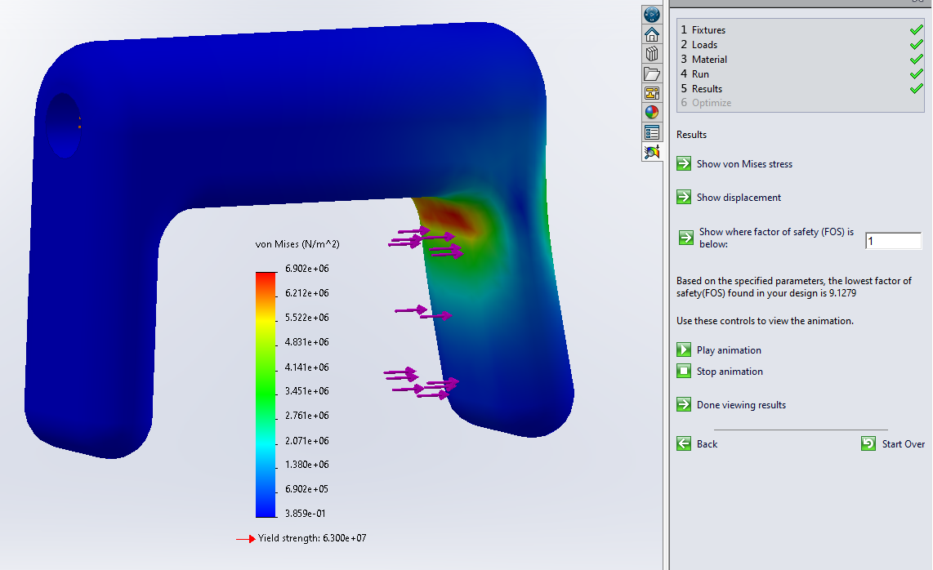

Figure 15 simulates the force on the lock if the door to the CLE were to be forced open by someone trying to open the door while the device is locked, meaning the hook is blocking the closer arm. According to the Solidworks simulation, the minimum Factor of Safety (FOS) is 9.13 throughout the entire hook. Since the force in the simulation is over a slightly larger area and the interior hole is coded as being immovable, we can lowball estimate a minimum FOS of 3-5, which still means a considerable amount of force (30-50 lbs) will be needed to break the hook. This means the more likely scenario of a break in will result in the hook just popping off, which will be easily replaced. Along with that, the potentiometer will also detect the door opening while locked and sound an alarm.

# 

# **References**

# 

[1]E. Coates, “Opto Switches,” Learnabout Electronics. Accessed: Jan. 21, 2024. [Online]. Available:<https://learnabout-electronics.org/Semiconductors/opto_54.php>

[2]“#01 What’s a Magnetic Sensor?,” Tutorials | Hall Sensors | Products | Asahi Kasei Microdevices (AKM). Accessed: Jan. 21, 2024. [Online]. Available:<https://www.akm.com/content/www/akm/us/en/products/hall-sensor/tutorial/magnetic-sensor.html>

[3]“Working principle of thermocouples,” https://www.omega.com/en-us/. Accessed: Jan. 21, 2024. [Online]. Available:<https://www.omega.com/en-us/resources/how-thermocouples-work>

[4]“What Is An Automatic Door Closer? | www.autodoorandhardware.com.” Accessed: Jan. 21, 2024. [Online]. Available:<https://www.autodoorandhardware.com/What-Is-An-Automatic-Door-Closer--s/120992.htm>

[5]“Cord Reels: Types, Configurations, Selection, and Requirements.” Accessed: Jan. 21, 2024. [Online]. Available:<https://www.iqsdirectory.com/articles/hose-reel/cord-reels.html>

[6]“All You Need to Know About Potentiometers,” CUI Devices. Accessed: Jan. 21, 2024. [Online]. Available:<https://www.cuidevices.com/blog/all-you-need-to-know-about-potentiometers>

[7]“Voltage Divider Circuits | Divider Circuits And Kirchhoff’s Laws | Electronics Textbook.” Accessed: Jan. 21, 2024. [Online]. Available:<https://www.allaboutcircuits.com/textbook/direct-current/chpt-6/voltage-divider-circuits/>

[8]jumpfactor, “What is RFID and how Does RFID Work?,” Lowry Solutions. Accessed: Jan. 21, 2024. [Online]. Available:<https://lowrysolutions.com/blog/how-rfid-and-rfid-readers-actually-work/>

[9]“How Does A Fingerprint Scanner Work — The Application Of Biometrics -.” Accessed: Jan. 21, 2024. [Online]. Available:<https://www.biopanelsystems.co.uk/how-does-a-fingerprint-scanner-work-the-application-of-biometrics/>

[10]“How Closers Internally Work | Norton Rixson Door Controls.” YouTube, YouTube, 1 June 2018, [www.youtube.com/watch?v=ueKuYcvDQHQ](http://www.youtube.com/watch?v=ueKuYcvDQHQ).

[11]“How Hydraulic Door Closer Working Principle Inside (Jianlai Building Material Factory).” Youtube, Youtube, 3 Nov. 2020, <https://www.youtube.com/watch?v=mXNhgCefKD8>.

[12]“Firebase Cloud Messaging,” Firebase. Accessed: Jan. 21, 2024. [Online]. Available:<https://firebase.google.com/docs/cloud-messaging>

[13]B. Lockwood, “How to Stop Your LED Lights from Flickering,” Brennan Electric. Accessed: Jan. 21, 2024. [Online]. Available:<https://brennan-electric.com/how-to-stop-your-led-lights-from-flickering/>

[14]“Adjusting Doors for Access | ADA National Network.” Accessed: Jan. 24, 2024. [Online]. Available:<https://adata.org/factsheet/adjusting-doors-access>

[15]S. U. Lee, “Hydraulic door closer,” EP0469697A1, Feb. 05, 1992 Accessed: Jan. 24, 2024. [Online]. Available:<https://patents.google.com/patent/EP0469697A1/en>

# 

# **Appendix**

# 

## Interview With Steven Lucero

Q. What materials should be used for the housing and arm? Could they be the same material?

A. 6061 alloys for aluminum could work, though you have to be mindful of what machines you are using, for example, aluminum has to be machined. A variety of materials should probably be used. In the optimal parts of the design, sheetless cut stainless steel, 3D printed, and aluminum materials should be used.

Q. What parts could be 3D printed for rapid prototyping?

A. The case and arms could be done with PLA rapid prototyping while the interior would likely not be rapidly prototyped.

Q. Would it be possible to utilize the rotation about the arm joint with a rotational

potentiometer? How about using a slide inside the main housing?

A. It is possible to utilize the rotation about the arm joint with a rotational potentiometer or a rotary encoder. You could potentially make the wire longer so the joint can be more tolerant to movement. Furthermore, an idea to use in the design is a type of mechanical component that permits rotation with wires on either side called a slip ring.

Q. What are some potential mounting tactics we can use to ensure the components that need to stick together can stick?

A. Some mounting methods could be using adhesives, making the top wider for the surface area, epoxy weld possible if permanent, 3M, sticky form, or other products that could be searched. Furthermore, you might want to revisit the clip idea as a way to stick things together. Also, the idea of potentially sharing hardware with other fixtures should be thought of.

Q. What is the possibility of being able to adjust the height of the PINpad? Possible telescoPINg rod?

A. Being able to adjust the height of the PIN pad is not really necessary.

Q. In order to make the arm able to contain a wire, how thick would the arm have to be?

A. You could keep the rotary on the top of the design potentially to contain the wire.

## 

## Figure 16: User Needs Flowchart

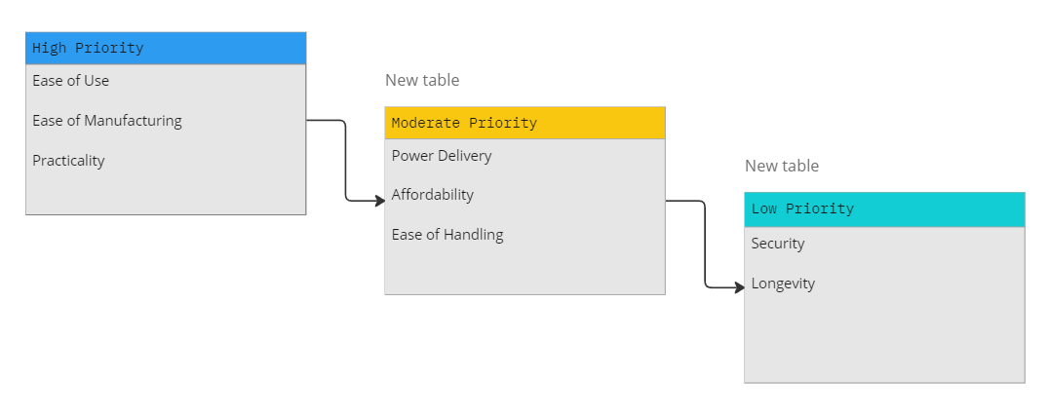

## 

## Figure 17: Engineering Design Specifications

| Metrics | Units | Corresponding User Needs | Range | Target Value | Direction of Improvement |
| --- | --- | --- | --- | --- | --- |
| Price | US Dollar | Affordability | $14-$984 | $≤$ $300 | To be minimized |
| Battery Life | Weeks | Power Delivery | 1- $∞$ | $≥$ 8 | To be maximized |
| Passive Operation | Binary | Ease of Handling | Fully Active to Fully Passive | Mostly Passive | To be maximized |
| Number of Components | Numerical | Ease of Manufacturing | 10-100 | $≥$ 20 | To be minimized |
| Established Technology | Binary | Practicality | Yes or No | Yes | N/A |
| Weight | Pounds | User Friendliness | 1 to 8 | 7 | To be minimized |